Landen Barber
3/8/26
Final Design Completion

Design Overview
My senior project is a one-handed accessibility controller which primarily uses gyro-based input to control computer actions like cursor movement and inputs using gestures.
These cursor movements and actions are triggered through natural motions like tilting rotating, or flicks. By mapping these movements into actions, it allows people with less fine motor control to activate buttons or macros that would otherwise be difficult to press on smaller buttons.
To help configure a device, the device will also provide adaptive assistance allowing it to learn the user’s movement patterns and automatically adjust sensitivity, filter strength, and gestures detection. These types of adjustment will make the controller more convenient to use as it improves the one-handed comfort and be more reliable over time.
Though if you also want to change some of these settings yourself, there will also be an on screen overlay to customize button mappings and other settings to the user’s preference. This overlay will also include a digital keyboard for typing.

Overall, many of the design changes from previous iterations have been about scaling back on less important mechanical aspects, like having a modular backplate, and focusing more on gyro functionality and making that work for the overall goal of making general use computers easier to work with by reducing reliance on fine motor control. A big part of this was expanding on the existing software plan and clarifying which function will handle what in the software flow.

Hardware Design Changes

Block Diagram
In terms of overall hardware component changes, there have not been any major changes compared to earlier designs, but something that has changed is the exclusion of shoulder buttons and other buttons on the handle of controller. This was done in essence of time and not being necessary to the design and goal of the controller.
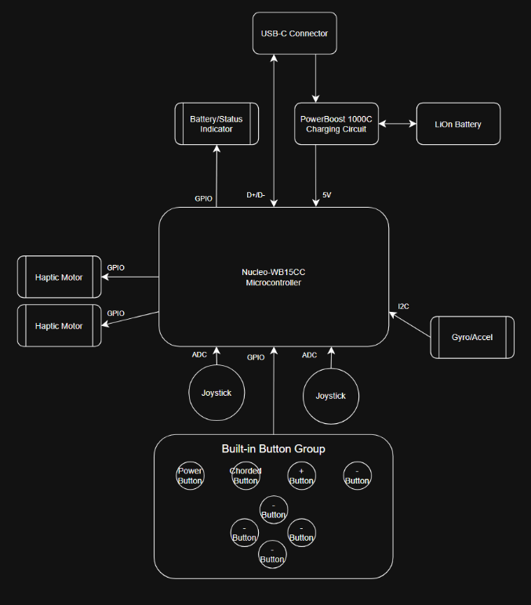
The hardware of this project starts with a USB-C breakout board that splits the data and power lines so that they can go to separate sources while also adding USB-C compatibility. The other aspect needed for wireless communication is the use of Bluetooth, this is one of the main reasons why I chose the Nucleo-WB155CC as it includes an on-board Bluetooth chip and native compatibility. While the data lines can be used by the Nucleo-WB15CC microcontroller, the power lines are fed into the power boost 1000C which acts as a uninterrupted power supply (UPS) and handles the battery connection and switches between using the battery or connected power source when needed. The battery is a 3.7v 500mWh battery which is booted to 5v by the power boost board. Another major component of this design is the ICM-20948 9-DoF IMU which includes the gyroscope, accelerometer, and MPU. This is the module that will detect the orientation and motion of the device allowing for the gesture and motion-based input. There are also other simple components like joysticks, buttons, and haptic motors in order to add basic I/O functionality to the controller allowing something to fall back to if gyro/gesture functionality is not properly configured.

Circuit Diagram
Because there were not any major differences in components, the overall circuitry also did not change much. Any differences that were made was to finish establishing the GPIO layout of the on-board pins and laying them out to easily be connected on a PCB board.
This circuit diagram explains how the systems components will be wired up on the PCB boards. At the top half of the diagram is the power circuit which starts with the USB-C breakout board allowing data and power lines to be split up and fed into the MCU and charging circuit respectively. Something to keep in mind was setting up the control pins of the USB-C adapter so that the power ranges could be correct. Otherwise, the grounds are all connected together and the battery is connected to the charging circuit using a JST-PH connector.
The bottom half of the diagram breaks down the individual components like the two joysticks, gyroscope, power led, haptic motors, and button connections. The Nucleo-WB15CC on the left side has plenty of GPIO pins that could be used for various buttons and control pins, to simplify the diagram a little, only the used GPIO pins are shown with the corresponding Pin names. The joystick on the other hand must use the 4 of the 10 ADC pins that the board and uses DMA to place the four values into corresponding registers. Lastly, the gyroscope must use I2C in order for the manometer to work. Other than power and ground, the connection only needs two pins, SCL and SDA.
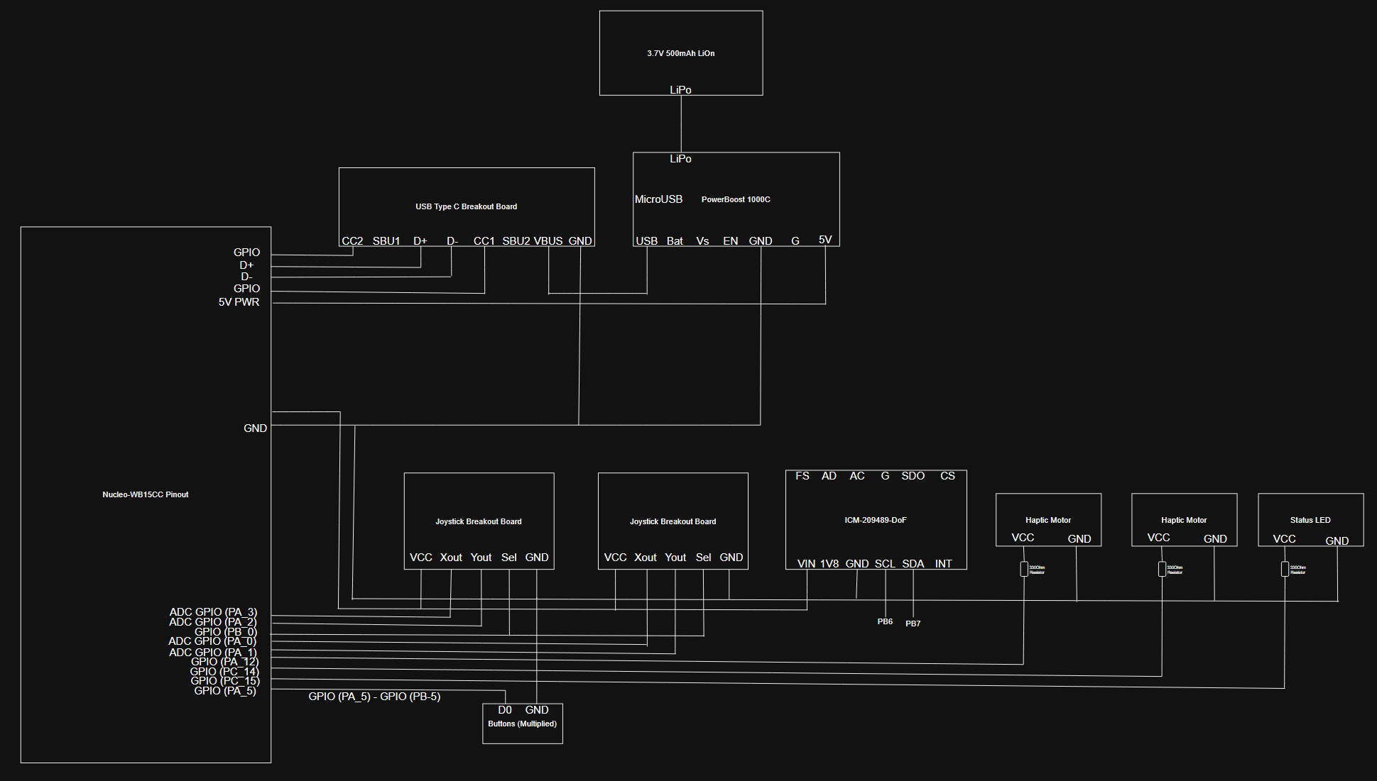

PCB Design
The biggest difference between the current design and the design from the start of the term is the usage of a PCB. I originally only planned to connect all the components together on a 3d printed base plate and connect them all with loose wires.
To reduce the overall horizontal footprint of the device, the internal components will be organized on a two-level stacked PCB design where the bottom board will hold the heavier components including the microcontroller, charging circuit, and gyroscope module, and the top board will hold the inputs and provide stability. There will also be an open connection to feed the haptic motors and battery indicator led.
The connection between the boards will be passed through the standoffs on each of the corners, allowing for more stability as well as functionality.
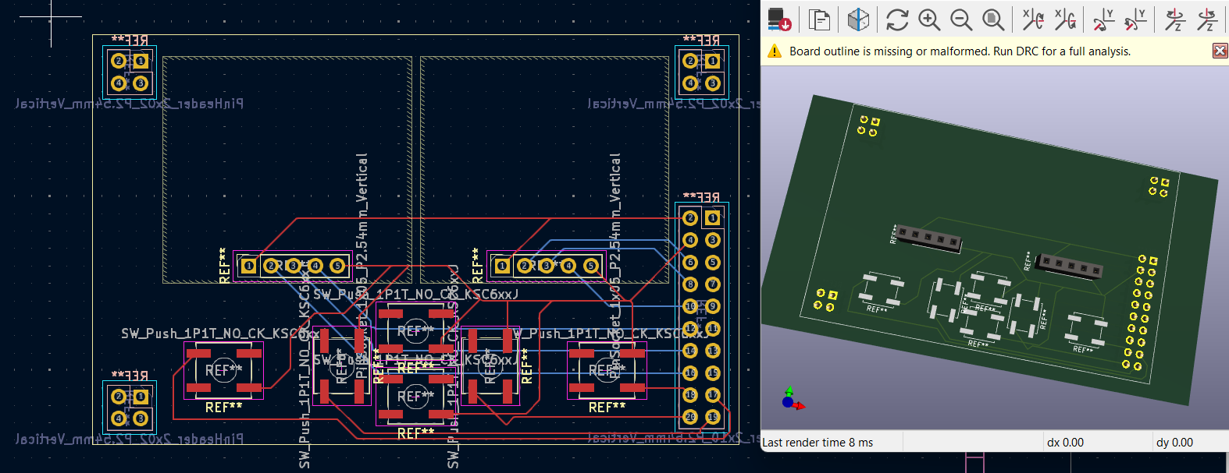

CAD Design
The CAD designs have already been changed fundamentally from the original concept, especially now that I am using a two-level PCB board to house components. Designing around a stacked PCB configuration allows for the head of the controller to have a smaller and therefore lighter form factor, good to make the design lighter and easier to wield.
Another big change from the original design that has been scrapped is the focus on having a removeable backplate and making it overly adjustable. Though an interesting idea, this only added to the complexity of the controllers 3d model, making it a more mechanically focused project instead of software-hardware codesign based project.
The current model consists of three main pieces. The controller face, which shields the central internal components and adds durability. There is also the handle of the controller, which is attached to the face by 2 10mm M4 screws, along with the rectangular block to wrap around, these should provide more than enough stability to allow the user to throw it around less carefully.
Unfortunately, nothing has been printed yet as I am waiting on the final dimensions on the interior PCB to be completed first.
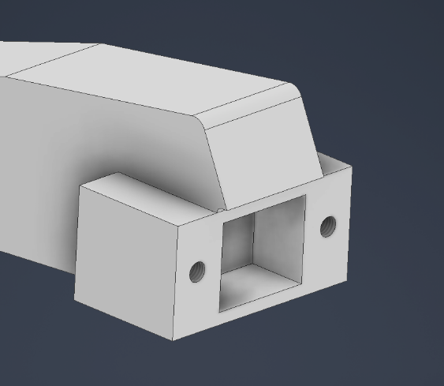
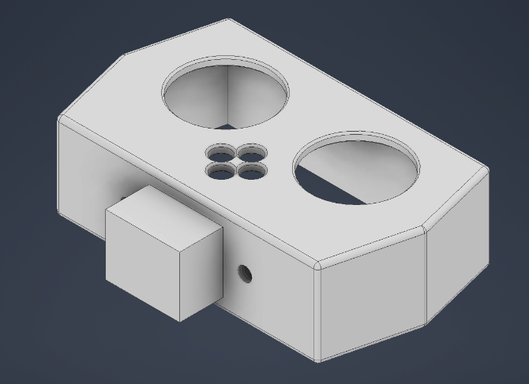

Sensor Test
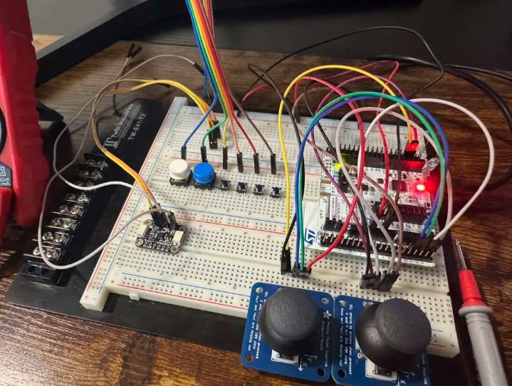
After verifying that each component functioned correctly, the next step was to test all the parts concurrently to ensure the GPIO configuration was solid and that all the data could be read quickly. Unfortunately, I am still stuck on two issues with the DMA/ADC circular loop involving complete transfer interrupts not being called as they should and finding that making the cycle time longer is crashing the program for a reason I don’t yet understand. Otherwise, all the components are working with their respective GPIO pin configuration which I plan to reference in the PCB.

Software Design Changes

Software Libraries and Platforms

Language: C
IDE: STM32Cube
Debugger: STM32 on board STLink
Version Control: GitLab

Libraries:
- CMSIS
  - Provides standardized APIs for Cortex-M33 CPU and fast math operations for filters
- STM32CubeWB HAL
  - Handles MCU peripherals (GPIO, timers, ADC, I2C/SPI, UART)
  - STM32CubeWB Middleware
  - Supports Bluetooth Low Energy (BLE) stack
- USB Device Library
  - Prebuilt STM32 library for USB communication.
  - IMU Drivers (ICM-20948)
  - Formats data and memory locations to help read raw sensor data via I2C.

Functional Description
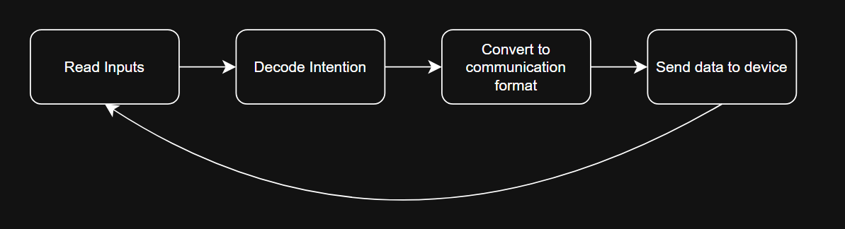
The basic loop of the controller is responsible for capturing the users’ inputs, processing them, and converting them to outputs for a connected device. It will start by initializing the hardware components before it enters its main loop.
In this loop it will continually read data from the buttons, joysticks, and gyro where it can then take all those inputs and process them within input managers and decoder functions so the desired output can be sent to the connected device using a communication manager.

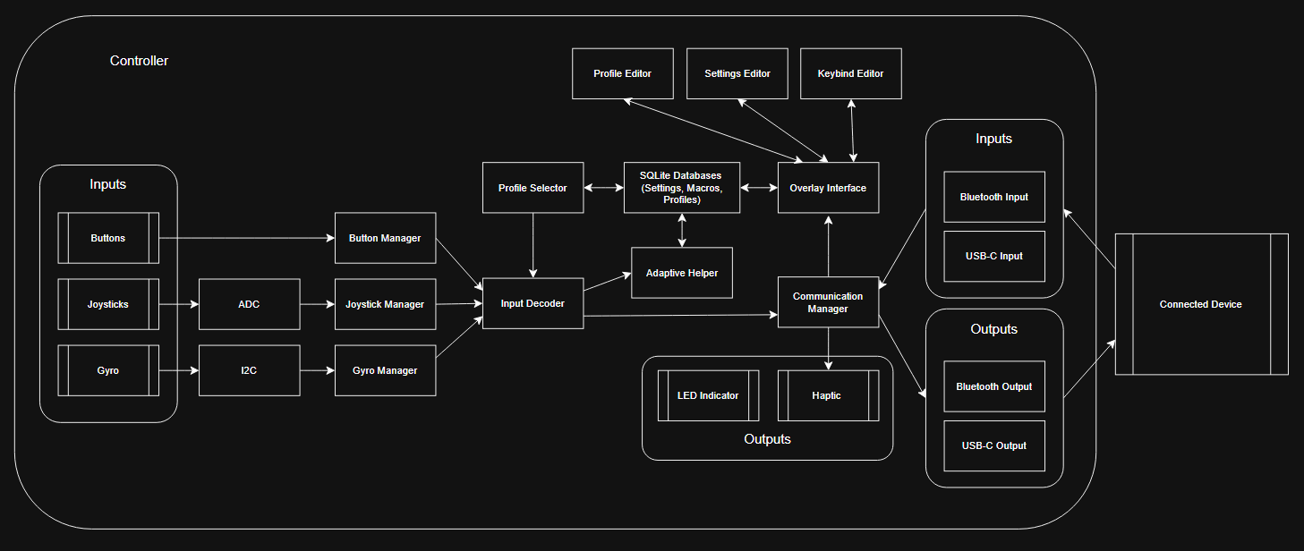
Function Descriptions

Input Managers:
Input managers are functions that are responsible for collecting data from the inputs, translating it into a useful format, and returning that data to the input decoder.
- Button Manager
Simply reads the pin states from the GPIO and returns it.
- Joystick Manager (See resource [12])
Since ADC data collection is automated from DMA/ADC cycle, this function packages these data registers into a struct and returns them.
- Gyro Manager
This manager is one of the most important because it will need to handle I2C communication and input smoothing algorithms (Seen below). Only to package and return that data for use by the input decoder.
Input Decoder:
This function is responsible for comparing the results from the managers to the selected profile and converting the inputs into recognizable buttons for the computer. This function also has the most important functionality of recognizing which filters to use and when a gesture is trying to be activated. This is the function that will be affected the most by settings changes.

Adaptive Helper:
The adaptive helper will have a few important functions. Including saving input data in the SQLite database, analyzing historical patterns, and adjusting parameters to make the system easier to use.
- Collecting data into SQLite database
Recording gyro magnitude, tilt angles, timing, etc. and storing it into the SQLite database for future analyzing.
- Analyze Patterns
Compute averages, common ranges, and when a gesture fails to activate.
- Adjust Parameters
Modify sensitivities, filter strengths, or gesture thresholds to better values.

Communication Manager:
This function has the important role of detecting which connection type is currently established and sending or receiving information from the connected device. IT will send this data to the connected device in HID format, which has room for change in X, Y movement, as well as buttons or keyboard presses. (See resource [8])
- Wired Communication through USB-C Port (See resource [10])
If a wired connection is established the communication will be sent through the USB-C cable to avoid the latency of Bluetooth communication.
- Bluetooth Communication through on board chip (See resource [1], [11])
If a wireless connection is being used, this function will provide the implementation on sending data through Bluetooth chip.

Overlay Interface:
This function will provide the implementation for the on-screen overlay, including the keyboard, key binds editor, settings editor, and profile editor. This function will only be called upon when a chosen button is pressed or held, but will have a fallback button if said button is not functioning.
- Keyboard
The most basic feature to allow the user to type using the controller, usable with both gyro-based aiming, and joystick based selecting of keys.
- Key binds Editor
With keyboard open, pressing a button will open the key binds editor allowing the user to change key binds.
- Settings Editor
With keyboard open, pressing a button will open the settings editor allowing the user to change settings.
- Profile Editor
With keyboard open, pressing a button will open the profile editor allowing the user to change profiles.

SQLite Database: (See resource [13] for more on setup)
This is not a function but an implementation of an SQLite database that will allow for long term storage of profiles and settings, as well as shorter term storage for the adaptive helper to store historical data for analyzing.

Profile Selector:
This function will refresh the key binds that the input decoder is using allowing for settings and key binds to be changed while active. Will also easily be able to handle multiple user profiles for different environments or users.

Algorithms

Sensor Filtering Algorithms
These functions are used to smooth IMU data as it is often too noisy to be used. (See resource [9], includes lots of information on gyro based input.)
- LPF
Used to eliminate high frequency noise, uses gyroscopic data to smooth movements.
    - y[n]=α⋅x[n]+(1−α)⋅y[n−1]
    - Smaller alpha value (0-1) means higher smoothing
- HPF
Useful in tracking sudden changes in movement, useful for recognizing gestures.
    - y[n]=α⋅(y[n−1]+x[n]−x[n−1])
- Complementary
Combines accelerometer and gyro inputs to produce more stable orientation data estimates.
    - angle=α⋅(angle+gyro⋅dt)+(1−α)⋅accel_angle

Gyro Algorithm
The gyro algorithm will start by using the magnitude to adaptively switch between low sensitivity and high Sens modes to differentiate between when the user is trying to use precise movement to press something of a screen, faster movement when trying to move the cursor further distances, and quick movement when the user is trying to activate a gesture.

Gesture Recognition
This algorithm’s purpose is to determine when a motion should trigger a command. The system will first read gyroscopic data like angular velocity and acceleration, and calculate magnitudes of motion, if the magnitudes pass an adjustable threshold and adjustable timing window, the movement will be treated as a gesture rather than normal cursor control. Gesture algorithms also commonly use state tracking and cooldown periods to prevent false positives (See resource [7]).

Adaptive Analyzer
During operation the controller will continuously save input data into the SQLite database, at periodic intervals, the adaptive helper will access this data and calculate statistical data such as average movement magnitude, common tilt ranges, and whether a gesture failed to activate or not from similar movements in quick succession. When these patterns are detected, the algorithm may slightly adjust system settings to try and match user behavior better. For example, if the system notices that repeat actions are needed to activate a gesture, the heper may try to increase the timing window, or lessen the movement magnitude needed to activate said gesture.

Resources
- [1] STMicroelectronics, “NUCLEO-WB15CC Evaluation Board,” STMicroelectronics. [Online]. Available: https://www.st.com/en/evaluation-tools/nucleo-wb15cc.html. Accessed: Mar. 8, 2026.
- [2] Adafruit Industries, “Adafruit PowerBoost 1000C – Load Share USB Charge Boost,” Adafruit Learning System. [Online]. Available: https://learn.adafruit.com/adafruit-powerboost-1000c-load-share-usb-charge-boost/downloads. Accessed: Mar. 8, 2026.
- [3] Adafruit Industries, “ICM-20948 9-DoF IMU Sensor,” Adafruit. [Online]. Available: https://www.adafruit.com/product/4554. Accessed: Mar. 8, 2026.
- [4] Adafruit Industries, “USB Type-C Breakout Board – Pinout Reference,” Adafruit. [Online]. Available: https://www.adafruit.com/product/4090. Accessed: Mar. 8, 2026.
- [5] SQLite Consortium, “SQLite Documentation,” SQLite.org. [Online]. Available: https://sqlite.org/docs.html. Accessed: Mar. 8, 2026.
- [6] VectorNav Technologies, “Filtering Basics for Inertial Sensors,” VectorNav Inertial Navigation Primer. [Online]. Available: https://www.vectornav.com/resources/inertial-navigation-primer/math-fundamentals/math-filtering. Accessed: Mar. 8, 2026.
- [7] M. A. Rahman et al., “Gesture Recognition Using Inertial Sensors: A Review,” Sensors, vol. 19, no. 9, 2019. [Online]. Available: https://pmc.ncbi.nlm.nih.gov/articles/PMC6603535/. Accessed: Mar. 8, 2026.
- [8] Microsoft, “Human Interface Devices (HID) – Windows Drivers,” Microsoft Learn. [Online]. Available: https://learn.microsoft.com/en-us/windows-hardware/drivers/ddi/_hid/. Accessed: Mar. 8, 2026.
- [9] JibbSmart, “Tight and Smooth: Soft Tiered Smoothing,” GyroWiki Blog. [Online]. Available: http://gyrowiki.jibbsmart.com/blog:tight-and-smooth:soft-tiered-smoothing. Accessed: Mar. 8, 2026.
- [10] ControllersTech, “STM32 USB CDC Example – Virtual COM Port Communication (No UART Needed),” ControllersTech, [Online]. Available: https://controllerstech.com/stm32-usb-pc-communication-no-uart/. Accessed: Mar. 8, 2026.
- [11] K. Magdy, “STM32 HC-05 Bluetooth Module Interfacing & Examples,” DeepBluEmbedded, [Online]. Available: https://deepbluembedded.com/stm32-hc-05-bluetooth-module-examples/. Accessed: Mar. 8, 2026.
- [12] ControllersTech, “STM32 ADC – Multiple Channels with Circular DMA,” ControllersTech, [Online]. Available: https://controllerstech.com/stm32-adc-multiple-channels-circular-dma/. Accessed: Mar. 8, 2026. (controllerstech.com)
- [13] Prisma, “Setting up a local SQLite database,” Prisma Data Guide. [Online]. Available: https://www.prisma.io/dataguide/sqlite/setting-up-a-local-sqlite-database. Accessed: Mar. 8, 2026.

